Open-Ended Lab Task: GitHub Integration and Concurrency in Java
Objective: In this lab, you will explore essential practices for using GitHub repository and understand multithreading and inter-thread communication in Java.
- Concurrency with Multithreading Mechanisms
  - Create a class with multiple threads that perform different tasks (e.g., one thread handles calculations, another handles data logging).
  - Implement the start, sleep, and stop functionalities to demonstrate different thread lifecycle states.
  - Use join() where necessary to ensure one thread completes before another begins, simulating dependency between threads.
  - Deliverable: Code implementing multithreading with clear comments explaining the use of each concurrency method (start, sleep, stop, and join).
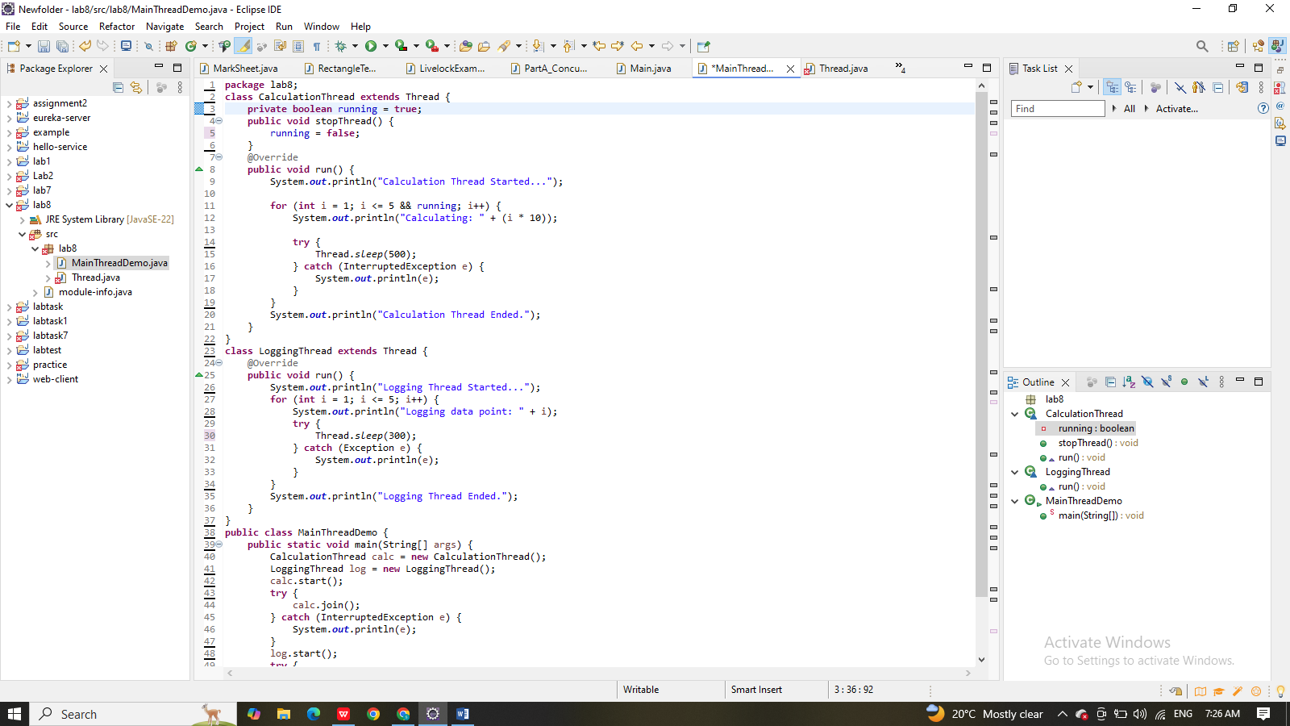
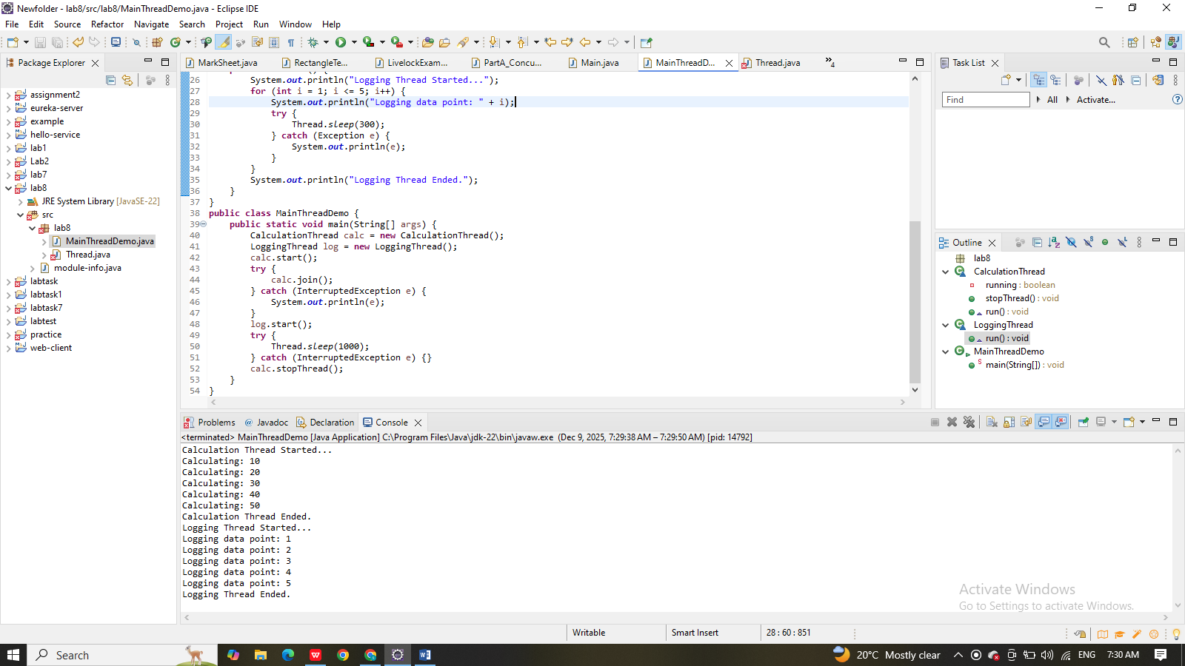
- Inter-Thread Communication Using Synchronization
  - Develop a program where two threads communicate via shared resources.
  - Use synchronization techniques (such as synchronized methods or blocks) to ensure that shared resources are accessed safely by each thread.
  - Example scenario: Implement a "Producer-Consumer" pattern, where one thread (Producer) adds items to a buffer, and another thread (Consumer) removes them, using wait() and notify() methods.
  - Deliverable: A fully functional inter-thread communication program demonstrating correct use of synchronization.
